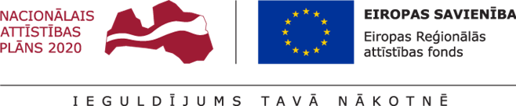

Annex 6

CURRICULUM VITAE (CV)

for preliminary selection of postdoctoral applications at the
Institute of Mathematics and Computer Science, University of Latvia

for submission to the State Education Development Agency (SEDA)
for the research application selection round
for
Activity 1.1.1.2 “Post-doctoral Research Aid” of the Specific Aid Objective 1.1.1 “To increase the research and innovative capacity of scientific institutions of Latvia and the ability to attract external financing, investing in human resources and infrastructure” of the Operational Programme “Growth and Employment”

1. General information
Family name, first name
Identity number
Telephone, mobile phone
Email address

2. Education
Higher education (the awarded degree, place and time) (a copy of the diploma appended in the supplement) (a formal acknowledgement from the Academic Information Centre (AIC) about the recognition of the doctoral degree if it has been awarded abroad - appended in the supplement)
Languages (speaking skills, reading skills, writing skills assessed according to the 5 point system where the assessment “5” is the highest score) (language proficiency certificates appended in the supplement)
3. Work experience
Name of the place of work, position held during the preceding 5 years
4. Publications
Publications (give the full time, co-authors, the year and place of publication, the number of pages; indicate if the publication has been prepared, submitted for publication or already published, give the website where it has been published) (append in the supplement):
in periodicals with a calculated citation index, indicating the impact factor of the periodical
in other peer-reviewed scientific periodicals
scientific monographs
parts of monographs
other publications (textbooks, study aids published by registered publishing houses; popular science publications, patents, licences etc.)
publication citation impact indicators Web of Science, Scopus
5. Pedagogical work and research
Acquisition of the lecturer’s work experience by participating in the implementation of Bachelor, Master and Doctoral study programmes
Independently delivered courses of lectures
Supervised or reviewed Master or Doctoral Theses
Participation in the implementation of research projects awarded as a result of a competition (title of the project, implementation period, provider of funding and position)
Participation in the administration of research projects awarded as a result of a competition (title of the Project, implementation period, provider of funding and position)

6. International cooperation
Internship and work at foreign higher educational institutions or research institutions for a period of at least six months
Internship or work at foreign higher educational institutions or research institutions for a period of 6-12 months (without interruption)
Lectures, schools etc. at foreign higher educational institutions and research institutions
Other
7. Other achievements related to the project application during the preceding 5 years

Post doctoral researcher _______________ /__________________/ ____._____. 20____.
signature name

* The IMCS UL will use the indicated data only for the purposes of project administration

